
- Name:BRIAN KIPKORIR KIPTUI
- Admission Number:BSCCS/2024/53968
- Course:COMPUTER SCIENCE
- Unit Code: BIT3208
- Unit Name: Advanced Web Design and Development
- Lecturer Name:MICHAEL NYORO
- Academic Year:YEAR III SEM II

Project Details

Project Title

Web-Based Academic Resource Sharing System
A Web-Based Academic Resource Sharing System is an online platform designed to help students and lecturers upload, share, manage, and access academic materials through a centralized web application.
The system allows users to:
- upload notes
- share assignments
- access revision materials
- download learning resources
- manage academic documents online
Selected Technologies
.Js + MySQL+html
I pick these because they are simple to use.
GitHub Link

https://github.com/Brian900bkk/AcademicResourceSystem.git

Table of Content
WEEK 1: LOCAL ENVIRONMENT SETUP…………………………………………………………………………………1
Figure 1. Apache and MySQL Running…………………………………………………………………………………1
Figure 2. Localhost Test Page…………………………………………………………………………………1
Fig 3: Hello World Test.…………………………………………………………………………………1
Fig 4: Database Connection Test.…………………………………………………………………………………1
WEEK 2: WIREFRAMES AND GUI DESIGN…………………………………………………………………………………2
Fig 1: Hand-drawn Wireframe.…………………………………………………………………………………2
Fig 2: Dashboard Layout Design.…………………………………………………………………………………2
Fig 3: Mobile View Mockup.…………………………………………………………………………………2
Fig 4: Color Theme and Navigation Structure.…………………………………………………………………………………2
FIG 5: GUI PROTOTYPE IN FIGMA.…………………………………………………………………………………2
WEEK 3.…………………………………………………………………………………3
Fig 1: JavaScript Form Validation…………………………………………………………………………………3
Fig 2: Password Strength Checker…………………………………………………………………………………3
Fig 3: PHP Syntax Practice…………………………………………………………………………………3
Fig 4: Database Connection Script…………………………………………………………………………………3
Fig 5: Dynamic User Input Handling…………………………………………………………………………………3
WEEK 4…………………………………………………………………………………4
Fig1: Login form…………………………………………………………………………………4
Fig 2: JavaScript Form ………………………………………………………………………………4
Fig 3: Folder structure…………………………………………………………………………………4
FIG 4: Database connection…………………………………………………………………………………4
Fig5 : GitHub weekly Update…………………………………………………………………………………4
WEEK 5 …………………………………………………………………………………5
FIG1: USERS TABLE…………………………………………………………………………………5
FIG2:USER EMAIL AND DECRYPTED PASSWORD…………………………………………………………………………………5
FIG3: DISPLAY ALL USER…………………………………………………………………………………5
FIG4: CREATION OF USER TABLE…………………………………………………………………………………5
FIG5: INSERTION IN TABLE…………………………………………………………………………………5

Week 1:Local Environment Setup
Fig 1: Installation of XAMPP
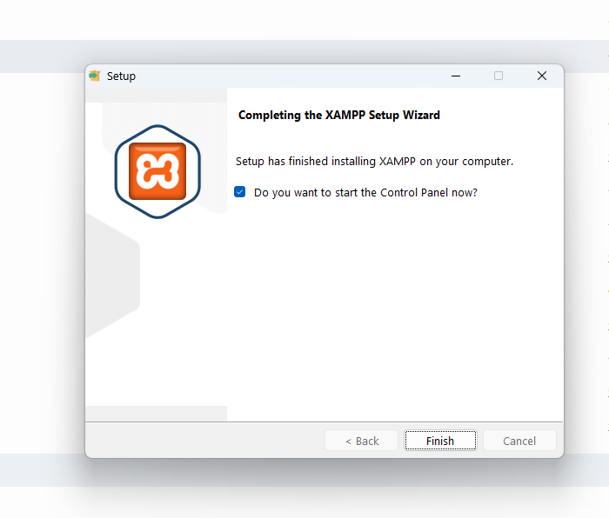

Fig 2: Apache and MySQL Running
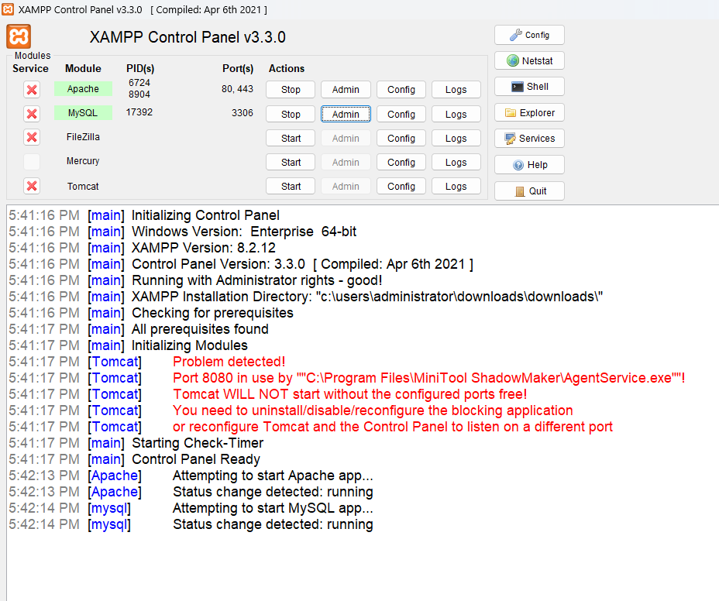

Fig 3: Localhost Test Page
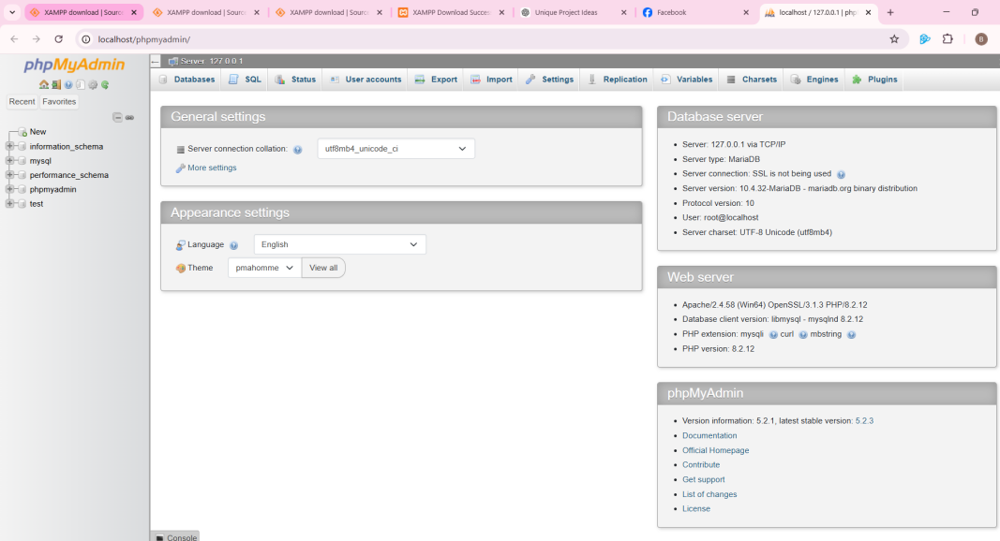

Fig 4:code testing

Simple code

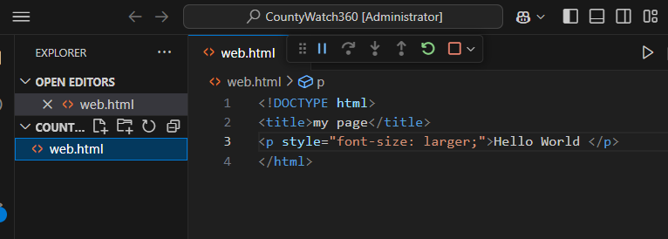

Results 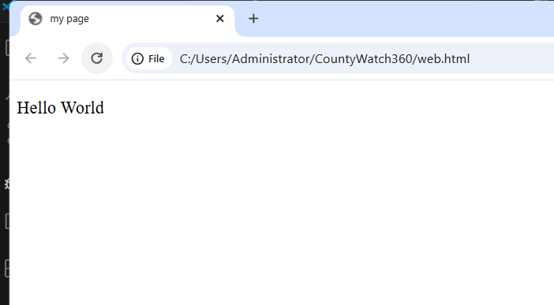

Fig 5: Database Connection Test
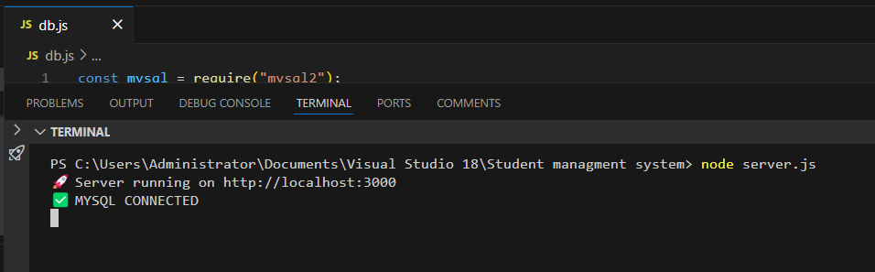

WEEK 2:Wireframes and GUI Design
User Interface Planning and System Design

Fig 1: Hand-drawn Wireframe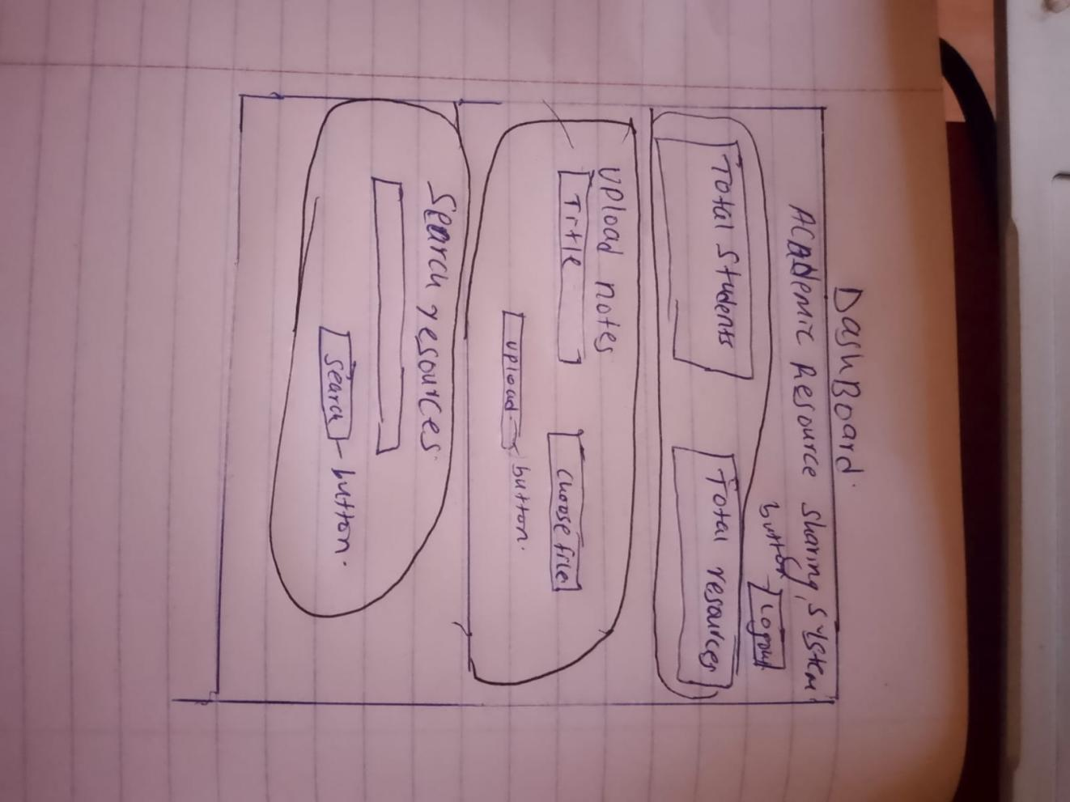It outlines the arrangement of key pages including the login page, dashboard, notes management section, announcements area, and administration panel. The wireframe provides a clear overview of the system's intended structure and navigation flow before development begins.

Fig 2: Dashboard Layout Design
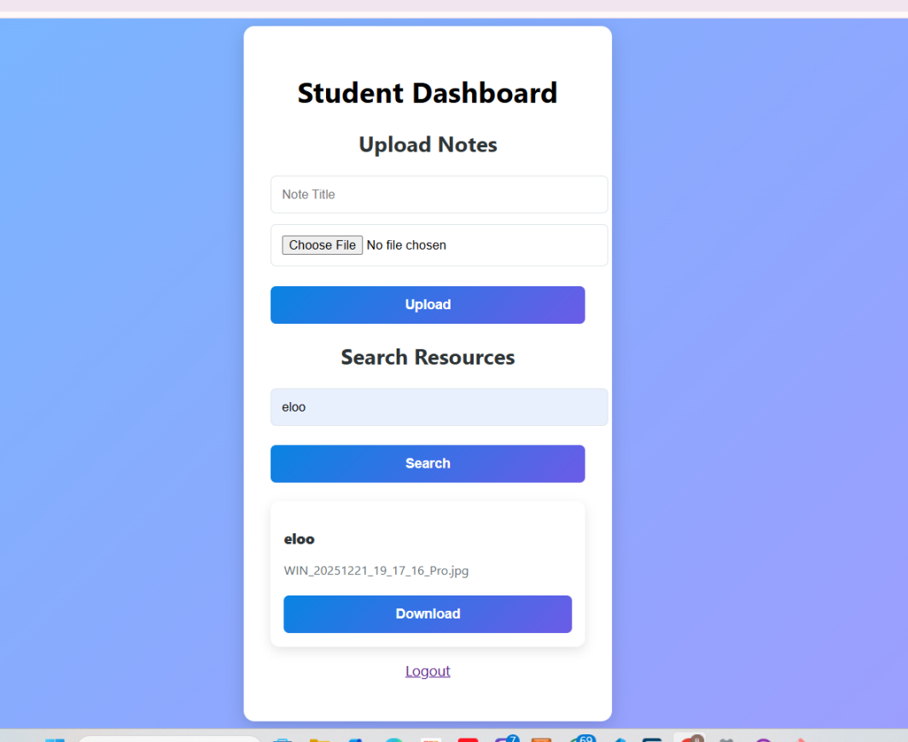
this the working dashboard of the system

Fig 3: Mobile View Mockup

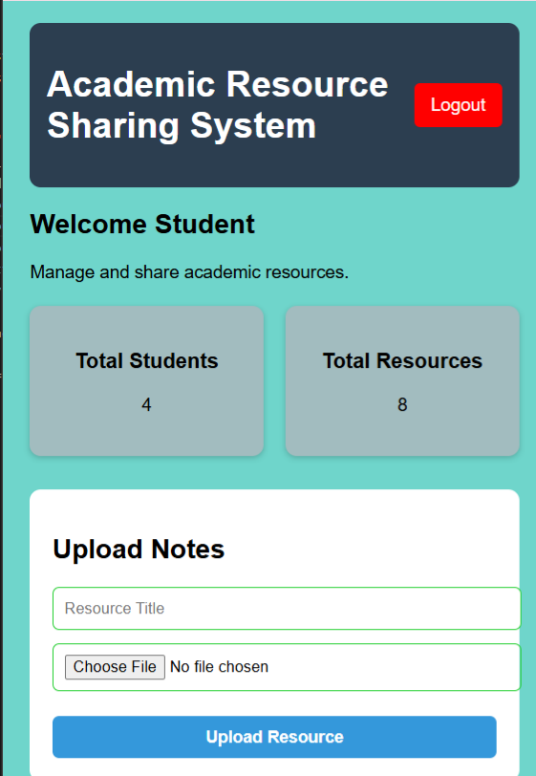

Fig 4: Color Theme and Navigation Structure
This illustrates the established visual aesthetics, contrasting colors, and navigation flow designed to ensure a clean and consistent user experience

Fig 5: GUI Prototype in Figma/Canva/Draw.io

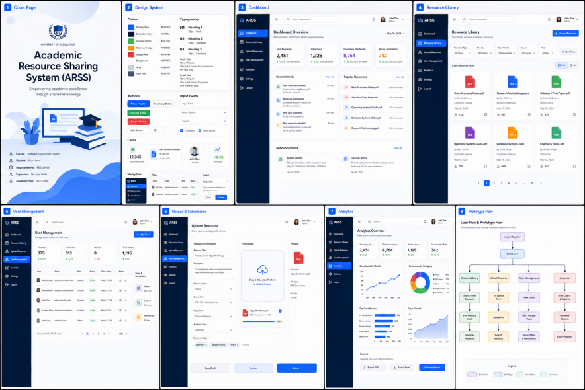

The prototype provides a visual representation of how users will interact with the system before actual development begins. It illustrates the layout of key components such as navigation menus, login forms, dashboards, buttons, and content sections.

Week 3: JavaScript and PHP Basics

Fig 1: JavaScript Form Validation

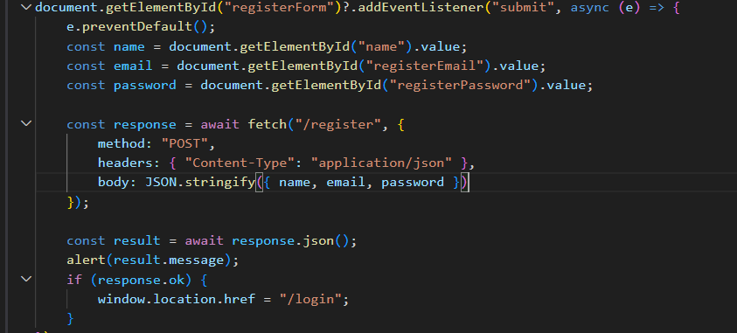
Use JavaScript to check:
Required fields are filled.
Email format is valid.
Passwords match
Fig 2: Password Strength Checker
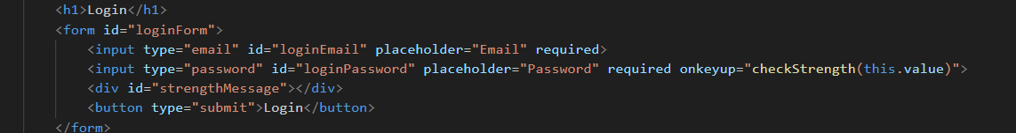
• Use JavaScript to check password strength (length, uppercase, numbers, symbols).

Fig 3: PHP Syntax Practice
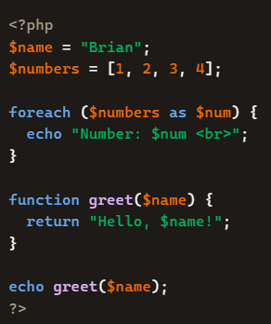It shows:
• Variables
• Arrays
• Loops
• Functions

Fig 4: Database Connection Script

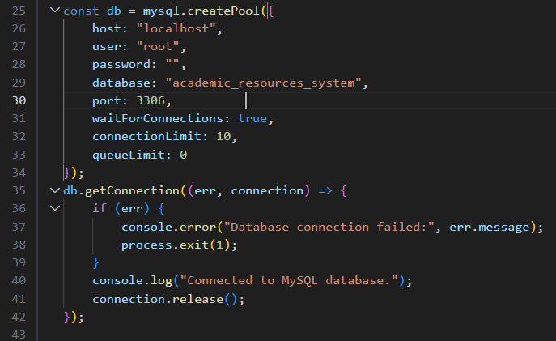

Show a PHP script connecting to MySQL.

Fig 5: Dynamic User Input Handling

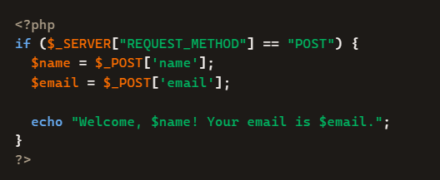

Show PHP handling form input (e.g., saving registration data).

Week 4:

Fig 1:login form
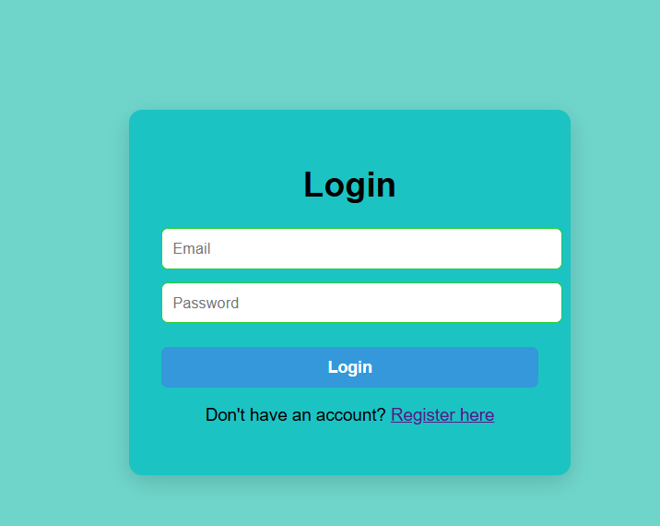 This shows the user-facing graphical interface built for authentication, providing clean input fields for standard user identification.

Fig 2:form validation

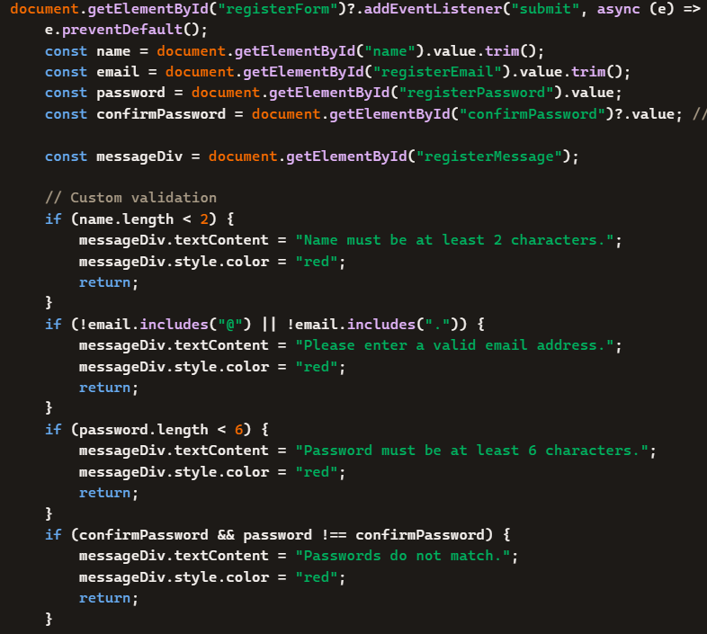The figure above demonstrates the form validation mechanism, where the system checks user input and displays appropriate error messages when invalid or incomplete data is entered. This ensures that only valid data is submitted and stored in the system.

Fig 3:Folder structure

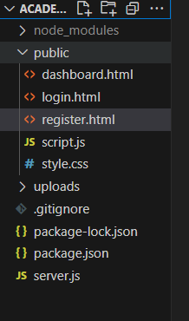 The structure separates frontend resources, backend logic, database files, and uploaded content to improve maintainability, scalability, and ease of development.

WEEK 5:
Fig1:Database screenshot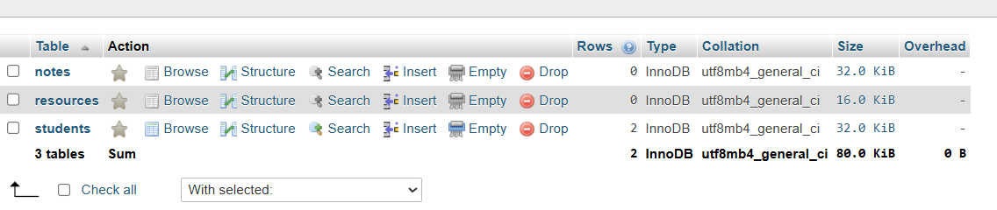
It contains the students email,pasword and name while the resources contain notes or learning materials
Fig 2: Table creation
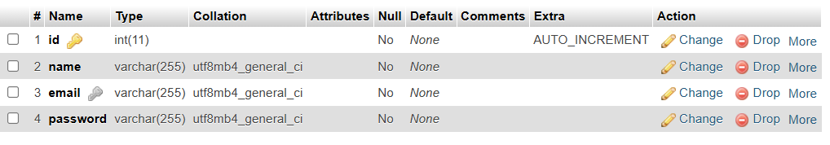shows how the registration table looks like
Fig3: Login database integration 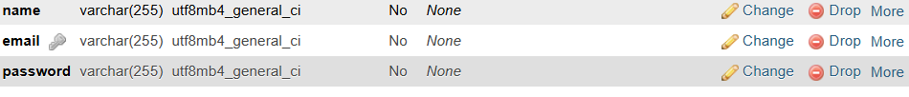The figure shows the login authentication process where user credentials are validated against database records before granting access to the system. This integration ensures secure user authentication and access control.
Fig 4: SQL query
Student table
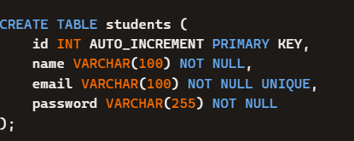 The figure shows the SQL query used to retrieve student information from the Students table. The query displays details such as student ID, name, email address, course, and other academic information stored in the database.

Resourse table
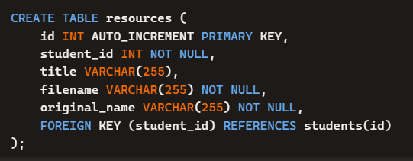 The figure shows the SQL query used to retrieve learning resources stored in the database. The table contains information such as resource title, file name, upload date, category, and the user who uploaded the resource.

